BLW EXPENDITURE ANALYSIS DASHBOARD

A Web-Based Platform for Purchase Order & CO6 Bill Tracking, Expenditure Visualization,
and AI-Assisted Audit Insight

PROJECT SYNOPSIS

Submitted for the Two-Week Industrial Internship Program at
Banaras Locomotive Works (BLW) EDP office, Varanasi
Submitted by
Priyanshu Tiwari
B.Tech, Computer Science & Engineering — 2nd Year
[Institute of Engineering & Technology Dr. Ram Manohar Lohia Avadh University]
Project Duration: [08-06-2026] – [18-06-2026] (2 Weeks)
Department / Section: [BLW EDP office]
Mentor / Guide: [Er.Teertha Biswas]

Signature: ______________

DECLARATION
I hereby declare that the work presented in this synopsis, titled “BLW Expenditure Analysis Dashboard,” is carried out by me as part of my two-week industrial internship at Banaras Locomotive Works (BLW), Varanasi, under the guidance of [Er.Teertha Biswas]. The system design, architecture, and implementation plan described herein represent my own understanding and planning, developed specifically for this internship engagement based on discussions with my mentor and review of BLW's existing PO and CO6 record-keeping practices.
This synopsis has not been submitted elsewhere for the award of any degree, diploma, or similar title.
Place: Varanasi
Date: ______________
Signature: ______________
Priyanshu Tiwari

ACKNOWLEDGEMENT
I would like to express my sincere gratitude to Banaras Locomotive Works (BLW), Varanasi, for providing me the opportunity to undertake this internship and work on a project of genuine organisational relevance.
I am especially thankful to [Mentor's Name], my internship guide, for their time and guidance in walking me through BLW's existing PO and CO6 record-keeping practices, which directly shaped the design of this system, and for the regular feedback that helped keep the project realistically scoped to a two-week timeframe.
I am also grateful to [College / Institute Name] for facilitating this internship as part of my academic curriculum, and to my faculty and peers for their continued encouragement throughout this period.
Priyanshu Tiwari (Intern)

Table of Contents
1. Introduction 5
2. About Banaras Locomotive Works 5
3. Existing System and Its Limitations 5
4. Objectives 6
5. Scope of the Project 6
6. Assumptions and Constraints 7
7. Methodology / Development Approach 7
8. System Requirements 8
9. System Architecture 8
10. Database Design 9
11. Technology Stack 10
12. Module-Wise Description 10
13. API Design / Endpoint Specification 11
14. AI Insights Engine — Working Principle 12
15. Forecasting Scenarios in Detail 12
16. Security and Data Privacy Considerations 13
17. Risk Management and Mitigation 13
18. Testing Strategy 14
19. Two-Week Project Timeline 15
20. Expected Outcomes 15
21. Future Scope and Enhancements 15
22. Conclusion 16
23. Glossary of Key Terms 16
24. SS of Project Dashboard 18
25. References 19

1. Introduction
Banaras Locomotive Works (BLW), Varanasi, is one of the principal locomotive manufacturing and maintenance units of Indian Railways. Its day-to-day operations involve substantial capital expenditure spread across multiple technical departments — Electrical, Mechanical, Signal & Telecom, and Civil Engineering. Every approved Purchase Order (PO) represents a sanctioned capital budget, while every CO6 Bill Registration represents an actual contractor payment claim raised against that sanction.
Reconciling sanctioned budgets with ongoing billing claims, tracking utilisation across departments, and anticipating future spending needs are essential to sound financial governance at BLW. At present, much of this reconciliation is carried out manually using registers and spreadsheets, which limits real-time visibility and makes it difficult to spot irregularities early. This project proposes a centralised, web-based Expenditure Analysis Dashboard that digitises this workflow and layers automated, AI-assisted analysis on top of it.
This document serves as the project synopsis: it explains the background and motivation for the project, the objectives and scope agreed for the two-week internship, the proposed system design, and the implementation plan that will be followed.

2. About Banaras Locomotive Works
Banaras Locomotive Works, located in Varanasi, Uttar Pradesh, is one of the long-standing production units of Indian Railways, primarily engaged in the manufacture and periodic overhaul of diesel-electric and electric locomotives, traction motors, and associated rolling-stock components. Over the years its mandate has broadened to include modernisation works, component overhaul, and indigenous manufacturing initiatives in line with Indian Railways' wider goals.
Like other production units, BLW's capital activity is governed by a structured budgeting process. Annual and supplementary budgets are sanctioned against specific Purchase Orders for materials, machinery, civil works, and contracted services. As work progresses, contractors and suppliers raise CO6 bills — formal claims for payment against completed or partially completed work — which are verified, passed, and cleared by the Accounts Department in coordination with the originating technical department.
The volume and spread of this activity across departments generates a continuous stream of financial records that must be tracked accurately in order to avoid budget overruns, payment delays, and audit objections — the exact need this project addresses.

3. Existing System and Its Limitations
BLW's expenditure tracking, like that of many production units, currently relies on a combination of physical registers, departmental spreadsheets, and periodic manual reconciliation between the Accounts wing and individual technical departments. While functional, this approach has accumulated several limitations as transaction volumes have grown:
- Fragmented Records — PO sanctions and CO6 claims are often maintained in separate files or registers by different departments, with no single consolidated source of truth.
- Delayed Visibility — Consolidated expenditure summaries typically reach senior officers and planning committees only at month-end or quarter-end, by which time corrective action is harder to take.
- Manual Cross-Checking — Verifying that a CO6 bill does not exceed its parent PO's remaining sanction, or that a mandatory Measurement Book (MB) entry exists, requires officers to manually trace records across registers.
- Limited Trend Analysis — Spreadsheets capture historical numbers but rarely surface seasonal patterns — such as the monsoon-season slowdown or the fiscal year-end surge — in a way that aids planning.
- No Forward-Planning Tool — There is presently no lightweight tool that lets planning officers simulate “what-if” spending scenarios before committing to a procurement strategy.
These limitations motivate the design of a single, web-based system that consolidates PO and CO6 data, automates routine checks, and presents the information through an interactive dashboard.

4. Objectives
- Digitise Purchase Order (PO) and CO6 bill records into a structured, searchable database.
- Build an interactive dashboard summarising total sanctioned amount, total claims, ledger efficiency, and month-wise/quarter-wise trends.
- Provide a department-wise breakdown of expenditure and budget utilisation for Electrical, Mechanical, Signal & Telecom, and Civil Engineering.
- Integrate an AI-assisted insights and chatbot module that flags audit-worthy anomalies and answers natural-language queries about the data.
- Lay the technical foundation for forward-looking expenditure forecasting under multiple planning scenarios.

5. Scope of the Project
Given the two-week duration of the internship, the project is scoped to deliver a working core of the system end-to-end, while the more advanced forecasting capability is planned as a natural Phase 2 extension. The synopsis describes the complete intended system; the immediate two-week deliverable concentrates on:
- The data layer and REST APIs for PO and CO6 records.
- The Overview, PO Registry, and CO6 Registry dashboard screens with live charts.
- A working AI insights / chatbot module for querying and auditing the data.
The following items are explicitly out of scope for the two-week period and are listed here for clarity: full multi-scenario forecasting (Section 15), role-based multi-user authentication, and integration with BLW's internal ERP/PFMS systems. These are discussed further as future enhancements in Section 21.

6. Assumptions and Constraints
- The dashboard is built and demonstrated using realistic sample/dummy PO and CO6 data, since live production data could not be exported for development purposes within the internship window.
- A stable internet connection is assumed for development and demonstration, since the database layer relies on MongoDB Atlas (cloud-hosted).
- The two-week timeframe assumes no major scope changes once development begins; any new requirement raised mid-way is logged for the future-scope discussion (Section 21) rather than absorbed into the current sprint.
- Department-wise budget head classifications used in the sample dataset follow the general structure described during the requirement-understanding phase (Day 1) and may need minor adjustment once mapped against BLW's exact official codes.

7. Methodology / Development Approach
The project follows a lightweight, iterative development approach suited to a short, two-week timeframe:
- Requirement Understanding — Reviewing sample PO and CO6 registers/spreadsheets used at BLW to understand field-level structure and terminology before any code is written.
- Incremental Build — Building the backend data layer first, followed by the frontend dashboard, followed by the AI insights layer, so each piece can be tested independently as it is completed.
- Continuous Testing — Verifying every REST endpoint with Postman before wiring it into the frontend, so issues are caught at the API layer rather than the UI layer.
- Daily Review — A brief end-of-day check against the timeline in Section 19 to re-prioritise remaining tasks where needed.

Tools used during development:
Tool | Purpose
Visual Studio Code | Primary code editor for both frontend and backend
Postman | Manual testing of REST API endpoints during development
Git | Version control for incremental, reviewable commits
MongoDB Compass / Atlas UI | Inspecting collections and verifying inserted records
Browser DevTools | Debugging frontend rendering and network calls

8. System Requirements
Category | Requirement
Development Hardware | Standard laptop/desktop with 8 GB RAM minimum and stable internet access (required for the cloud-hosted database)
Runtime | Node.js v18 or later, npm
Database | MongoDB Atlas account (free/shared tier is sufficient for development)
Browser | A current version of Chrome, Edge, or Firefox
Optional Tooling | Postman (API testing), Git (version control)

9. System Architecture
The system follows a three-tier, full-stack architecture: a React single-page application on the client, an Express.js REST API server in the middle, and a MongoDB Atlas database at the persistence layer.
+---------------------------------------------------+
| CLIENT (Browser) |
| React 18 SPA — built/served via Vite |
| Overview | PO Registry | CO6 Registry | AI Tab |
+----------------------+------------------------------+
| HTTPS / REST (JSON)
v
+----------------------+------------------------------+
| APPLICATION SERVER |
| Express.js on Node.js |
| /api/expenditure/pos /api/expenditure/co6 |
| /api/expenditure/insights (AI Engine) |
+----------------------+------------------------------+
| MongoDB Node.js Driver
v
+----------------------+------------------------------+
| PERSISTENCE LAYER |
| MongoDB Atlas (Cloud) |
| po_records co6_records |
+-----------------------------------------------------+

Data flows from the browser to the API layer as JSON over HTTPS, and from the API layer to MongoDB via the official MongoDB Node.js driver. Any new PO or CO6 entry — whether typed in directly or uploaded via an Excel sheet — immediately reflects across every connected dashboard view, since all tabs read from the same live collections rather than a cached snapshot.

9.1 Presentation Layer
The React SPA is organised into tabs (Overview, PO Registry, CO6 Registry, AI Insights) that share a common layout shell. Each tab is responsible for fetching its own data on mount and re-fetching after a create/edit action, keeping individual components simple and independently testable.

9.2 Application Layer
The Express.js server exposes a small, predictable set of REST endpoints (detailed in Section 13). It is also responsible for basic request validation — for example, rejecting a CO6 submission that is missing a department or amount field — before any database write occurs.

9.3 Persistence Layer
MongoDB Atlas was chosen over a relational database because PO and CO6 records can carry slightly different optional fields across departments (e.g., civil works bills may reference a measurement book entry that does not apply to a signalling contract), and a flexible-schema document store accommodates this without frequent migrations.

10. Database Design
Two primary collections back the application: po_records, holding master Purchase Order sanctions, and co6_records, holding contractor bill claims raised against those sanctions.

10.1 po_records Collection
Field | Type | Description
poNumber | String | Unique Purchase Order identifier
department | String | Issuing department — Electrical / Mechanical / S&T / Civil
budgetHead | String | Budget head/classification under which the PO is sanctioned
sanctionedAmount | Number | Sanctioned value of the PO, in ₹ lakhs
dateOfSanction | Date | Date the PO was approved
validUpto | Date | Validity period of the sanction
status | String | Active / Closed / Lapsed

10.2 co6_records Collection
Field | Type | Description
co6Number | String | Unique CO6 bill identifier
poReference | String | Linked PO number against which the bill is raised
department | String | Department raising the claim
billAmount | Number | Claimed amount, in ₹ lakhs
dateOfClaim | Date | Date the bill was raised
mbRecorded | Boolean | Whether the Measurement Book entry exists for this claim
paymentStatus | String | Pending / Passed / Returned
Both collections are indexed on department and date fields to keep dashboard queries responsive as record volume grows. The poReference field provides the logical link used to compute per-PO utilisation in both the Overview and AI Insights modules.

11. Technology Stack
Layer | Technology | Why It Was Chosen
Frontend | React 18 (Vite) | Component-based architecture suited to a multi-tab dashboard; Vite gives near-instant dev-server reloads.
Visualization | Chart.js / Recharts | Mature charting library with solid support for the line, bar, and area charts needed for trend visualisation.
UI Components | MUI / Lucide icons | Ready-made, accessible form and table components speed up development within a short timeframe.
Backend | Node.js + Express.js | Lightweight, well-documented REST framework that pairs naturally with a React frontend (the MERN stack).
Database | MongoDB Atlas | Schema-flexible NoSQL store suited to PO/CO6 records that vary slightly across departments; cloud hosting avoids local server setup.
AI / Insights Layer | Language-model-based insights engine | Adds natural-language querying and automated audit flagging without hand-coding a bespoke rule engine for every check.

12. Module-Wise Description

12.1 Overview Dashboard
The landing tab presents top-line KPIs — total sanctioned amount, total claims raised, and an overall ledger efficiency figure — alongside a monthly expenditure trend chart. It is designed to answer, in a single glance, “how much has been sanctioned, how much has been claimed, and is that trend healthy.”

12.2 PO Registry
A filterable, sortable table listing every master Purchase Order, with department-wise filtering and a modal form to add or edit entries. Each row links forward to the CO6 claims raised against it, so an officer can quickly see how much of a given sanction remains unutilised.

12.3 CO6 Registry
A corresponding table of contractor bill registrations, linked back to their parent PO via poReference, supporting the same filter-and-edit workflow as the PO Registry. Bills missing a Measurement Book entry are visually flagged for quick identification.

12.4 AI Insights & Chatbot
This module analyses the live PO/CO6 data to compute a sanction-utilisation index and a passing-efficiency ratio (see Section 14), flags bills missing MB records or dispatch logs, and answers natural-language questions about the dataset — for example, “which department is closest to exhausting its sanction this quarter.”

12.5 Forecasting Module (Phase 2)
Designed to project expenditure over a 3–24 month horizon under three planning strategies, while accounting for seasonal effects such as the August monsoon slowdown, the winter mobilisation sprint, and the March fiscal year-end closeout surge. This module is architected alongside the rest of the system but is positioned as the next phase once a stable volume of historical PO/CO6 data is available to forecast against — see Section 15 for the detailed scenario design.

13. API Design / Endpoint Specification
Method | Endpoint | Description
GET | /api/expenditure/pos | Returns PO records, optionally filtered by department or date range
POST | /api/expenditure/pos | Creates a new PO record
GET | /api/expenditure/co6 | Returns CO6 bill records
POST | /api/expenditure/co6 | Creates a new CO6 bill record
POST | /api/expenditure/insights | Runs the AI insights engine over current data and returns audit observations
POST | /api/expenditure/forecast | (Phase 2) Returns a projected expenditure curve for a chosen horizon and scenario

Sample request body for creating a CO6 record:
POST /api/expenditure/co6
{
"co6Number": "CO6-2026-0451",
"poReference": "PO-2025-1187",
"department": "Electrical",
"billAmount": 12.4,
"dateOfClaim": "2026-03-18",
"mbRecorded": true
}

14. AI Insights Engine — Working Principle
The insights engine processes the current PO and CO6 collections on demand rather than relying on a precomputed snapshot, so every report reflects the latest data. It centres on two core metrics:
- Sanction Utilisation Index — the proportion of a PO's sanctioned amount that has been claimed to date, expressed as a percentage (total CO6 claims passed against that PO, divided by the PO's sanctioned amount).
- Passing Efficiency Ratio — the proportion of CO6 bills raised in a given month that have actually been marked 'Passed' rather than left pending or returned.
Records are also screened against simple risk rules — for instance, a CO6 bill with mbRecorded set to false is flagged as an audit risk, since Measurement Book entries are a mandatory supporting record for contractor payments.

Sample output returned by the /api/expenditure/insights endpoint for a small dataset:
{
"summary": {
"totalSanctioned": 482.5,
"totalClaimed": 311.2,
"ledgerEfficiency": "64.5%"
},
"flags": [
{ "co6Number": "CO6-2026-0298", "issue": "Missing MB record",
"department": "Civil" },
{ "co6Number": "CO6-2026-0301",
"issue": "Claim nearing PO exhaustion (92%)",
"department": "Electrical" }
]
}

15. Forecasting Scenarios in Detail
The forecasting module (Phase 2) is designed around three planning strategies that planning officers can choose between when projecting future expenditure:
Scenario | Description | Risk Level
Baseline Capital Expansion | Projects future spend using the historical seasonal pattern observed in past PO/CO6 data, with no additional growth assumption | Low
Accelerated High-Speed Modernization | Models an aggressive investment ramp-up, useful for planning around modernisation pushes or year-end utilisation drives | High
Conservative Frugal Allocation | Simulates restrained spending, useful for planning during budget-constrained periods | Low

Each monthly projection is also adjusted using seasonal indices that reflect Indian Railways' typical annual spending pattern:
Period | Seasonal Index | Interpretation
August (Monsoon) | ≈ 0.71 | Outdoor civil and track works slow down, contracting claims by roughly 30%
Winter (Nov–Feb) | ≈ 1.15 | Peak contractor mobilisation, particularly in electrical and signalling work
March (Fiscal Close) | ≈ 1.44 | A sharp surge in billing claims as the financial year closes out

Conceptually, a projected monthly amount is computed by taking the historical monthly average for that budget head, applying the chosen scenario's growth multiplier, and then applying the seasonal index for that month:
projectedAmount = historicalMonthlyAverage
× scenarioMultiplier
× seasonalIndex[month]

A confidence figure is also attached to each projected month, decreasing gradually the further out the projection extends, to make clear that near-term forecasts are more reliable than those many months ahead.

16. Security and Data Privacy Considerations
- Database credentials (MongoDB Atlas connection string) are kept in environment variables and are never committed to version control.
- Numerical and metadata processing for the AI insights module happens within the application's own backend request handling, rather than being sent to an unrelated third-party analytics service.
- Basic request validation on the backend rejects malformed PO/CO6 submissions before they reach the database, reducing the risk of corrupted records.
- Role-based access control is identified as a near-term enhancement (Section 21) so that, in a future version, only authorised users can create or edit financial records.

17. Risk Management and Mitigation
Risk | Likelihood | Mitigation
Limited time to cover the full forecasting module | High | Treated as Phase 2; core tracking and insights are delivered first
Cloud database connectivity issues during the demo | Low | A local MongoDB fallback is kept ready as a backup
Inconsistent sample data slowing UI testing | Medium | The dummy dataset is validated early (Day 1–2) before UI work begins
Scope creep from new feature requests mid-sprint | Medium | New requests are logged under Future Scope (Section 21) rather than added mid-sprint

18. Testing Strategy
- API-Level Testing — Each REST endpoint is exercised with Postman for both valid and invalid payloads before the frontend is wired up to it.
- Edge-Case Handling — Empty datasets (e.g., a department with no POs yet) and zero-division cases in ratio calculations are checked explicitly so the dashboard degrades gracefully rather than erroring out.
- UI Verification — Each tab is manually checked after every significant change to confirm that newly added PO/CO6 records appear immediately across the Overview, Registry, and AI Insights views.
- Cross-Browser Check — The dashboard is verified in at least two modern browsers to catch any rendering inconsistencies before the final demonstration.

19. Two-Week Project Timeline
Day | Focus Area
Day 1 | Requirement understanding; review of sample PO/CO6 data formats used at BLW
Day 2 | Database schema design (po_records, co6_records); MongoDB Atlas cluster setup
Day 3 | Express.js server scaffolding; PO CRUD endpoints
Day 4 | CO6 CRUD endpoints; endpoint testing in Postman
Day 5 | Backend review and buffer day for fixes
Day 6 | React + Vite project scaffolding; Overview tab layout
Day 7 | PO Registry and CO6 Registry tab development
Day 8 | Chart integration and AI insights module integration
Day 9 | End-to-end testing, bug fixing, UI polish
Day 10 | Documentation, synopsis/report finalisation, and final demonstration

20. Expected Outcomes
- A functioning, full-stack expenditure dashboard covering PO and CO6 data entry, visualisation, and AI-assisted insights.
- Hands-on experience applying the MERN stack to a real organisational use case within Indian Railways.
- Practical exposure to integrating AI/LLM-based features into a production-style application.
- A clearer, data-backed view of departmental budget utilisation that can support faster decision-making by BLW's Accounts wing.
- A documented, extensible codebase that can support the planned forecasting module and further enhancements in subsequent phases.

21. Future Scope and Enhancements
- Role-based authentication with distinct Officer, Auditor, and Admin views and permissions.
- Full implementation of the multi-scenario, seasonally-adjusted forecasting module described in Section 15.
- Export of dashboard views and audit reports to PDF or Excel for offline circulation.
- Automated alerts when a department's CO6 claims approach a defined threshold of its PO sanction.
- Integration with BLW's internal ERP/PFMS data feeds, where organisationally permitted, to reduce duplicate data entry.

22. Conclusion
The BLW Expenditure Analysis Dashboard aims to replace fragmented, manual expenditure tracking with a single, real-time platform that maps contractor billing claims against sanctioned budgets, surfaces audit-worthy anomalies automatically, and — in its next phase — supports scenario-based expenditure forecasting. Within the two-week internship window, the project will deliver a working core of this system: a digitised PO/CO6 data layer, an interactive dashboard, and an AI-assisted insights module, demonstrating both the technical feasibility of the approach and its practical value to BLW's accounts administration.

23. Glossary of Key Terms
Term | Meaning
PO (Purchase Order) | A sanctioned capital budget document authorising procurement of goods, machinery, or contracted services
CO6 | A contractor bill registration/claim format used to bill against a sanctioned PO
MB (Measurement Book) | An official record of work measured and verified on-site, required to support contractor payment claims
Budget Head | A classification code under which expenditure is sanctioned and tracked
Ledger Efficiency | A summary measure of how much of the sanctioned budget has been productively utilised
Fiscal Year-End | The close of Indian Railways' financial year (31 March), historically associated with a surge in billing claims
BLW | Banaras Locomotive Works, Varanasi

24. SS of Project Dashboard

24.1 Overview Dashboard -

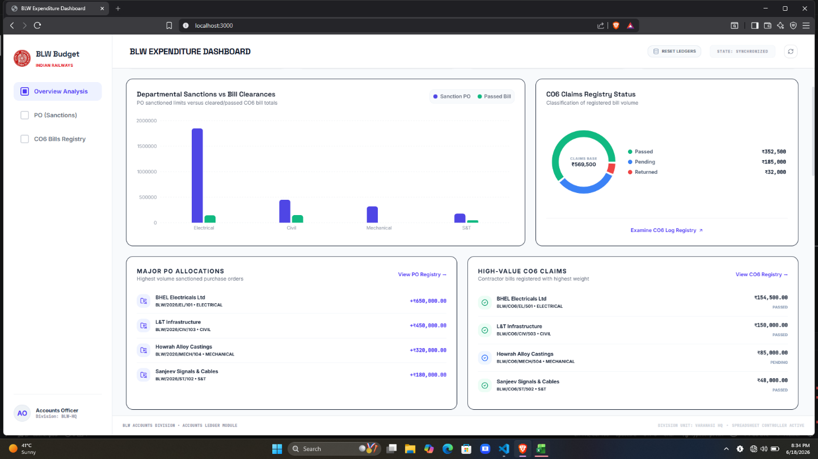

24.2 Forecasting Module (Local LLM) -

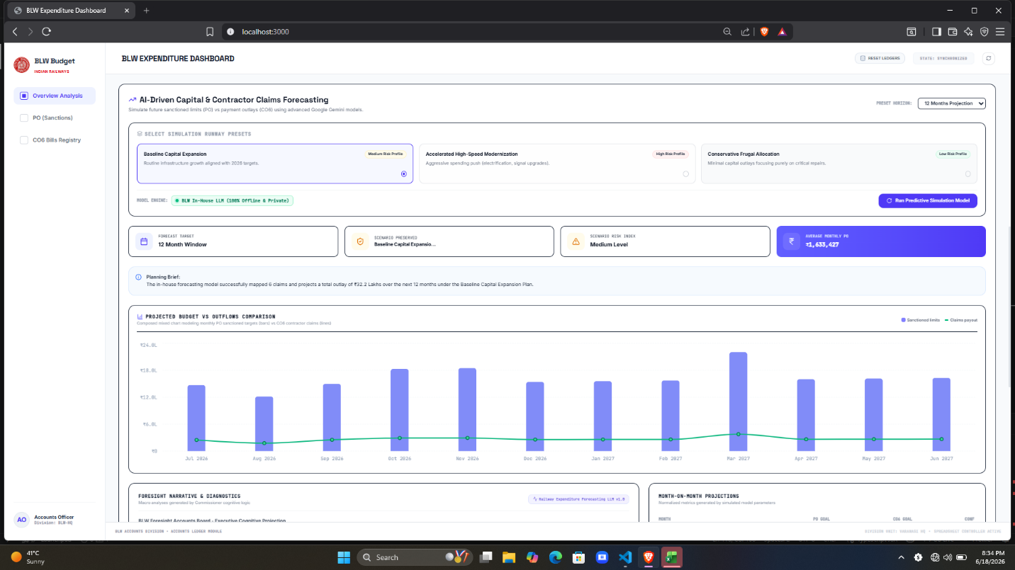

24.3 PO Registry -

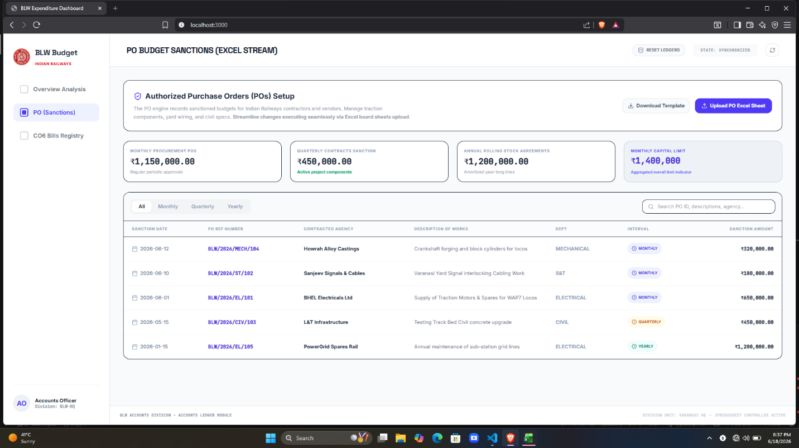

24.4 CO6 Registry -

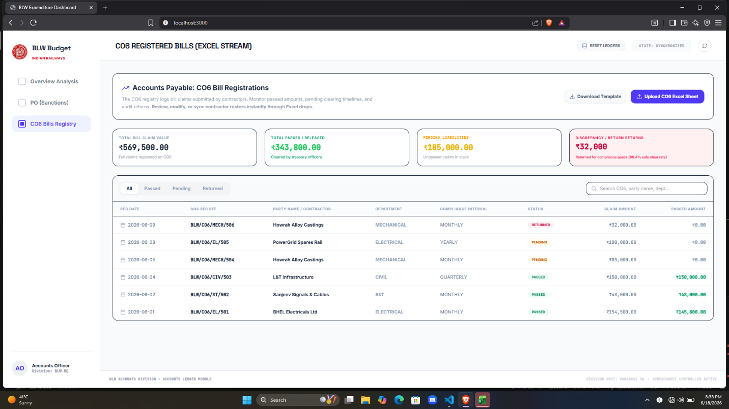

24.5 AI Insights & Chatbot –

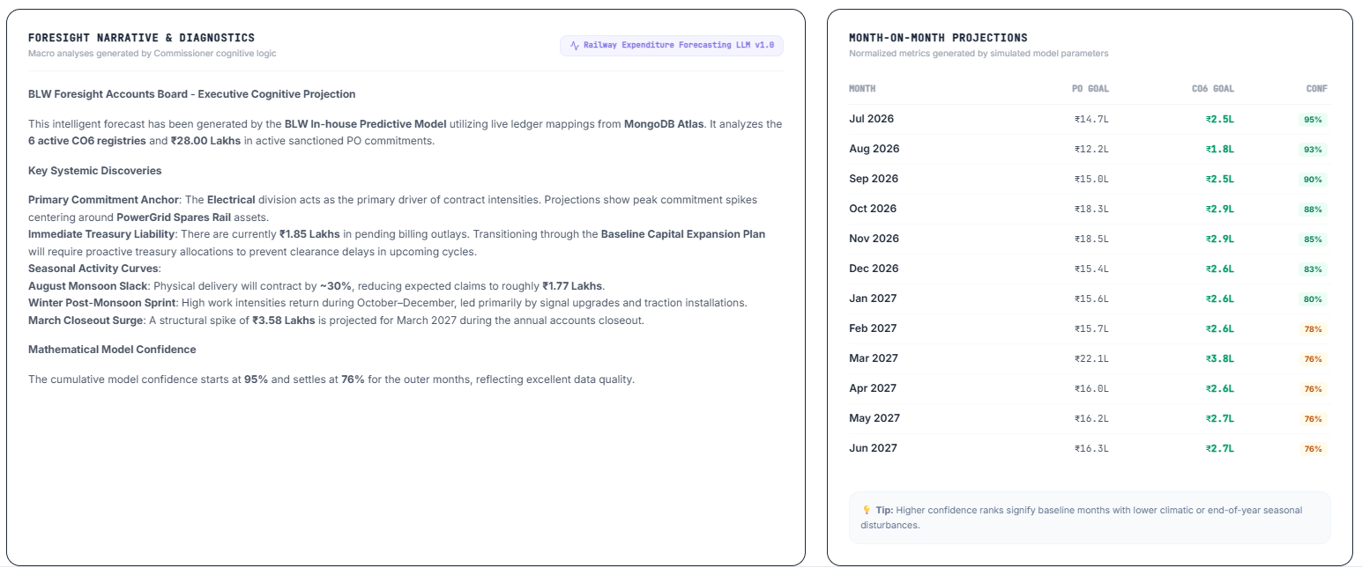

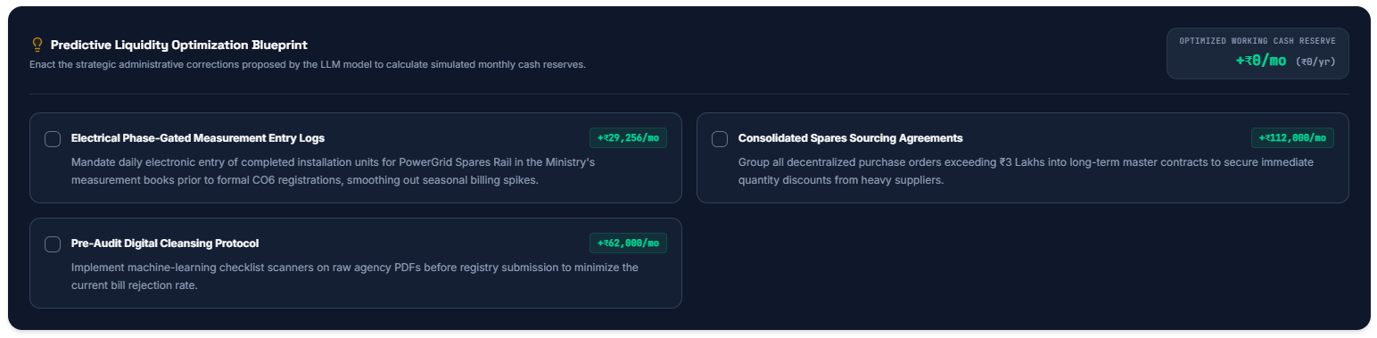

25. References
- React documentation — react.dev
- Express.js documentation — expressjs.com
- MongoDB documentation — mongodb.com/docs
- Chart.js documentation — chartjs.org
- Indian Railways financial and procurement terminology, as used in BLW's internal PO/CO6 registers
- For Live Project - https://github.com/Dev-priyanshu-tiwari

